**ST. ANDREWS INSTITUTE**

**OF TECHNOLOGY & MANAGEMENT**

**Gurugram Delhi (NCR)**

**Approved by AICTE, Govt. of India, New Delhi**

**Affiliated to Maharshi Dayanand University**

**‘A+’ Grade State University, accredited by NAAC**

**Session: 2025 – 2026**



**Problem Solving Techniques**

**Course Code: 25BCA401SEC01**

**Semester: 1st**

**Bachelor of Computer Applications**

**Submitted By**

**Name: Piyanshu Singh**

**Roll No.: 259079**

**DEPARTMENT**

**OF**

**COMPUTER APPLICATIONS**

1. Write a C Program Converting degrees Celsius to Fahrenheit and vice versa

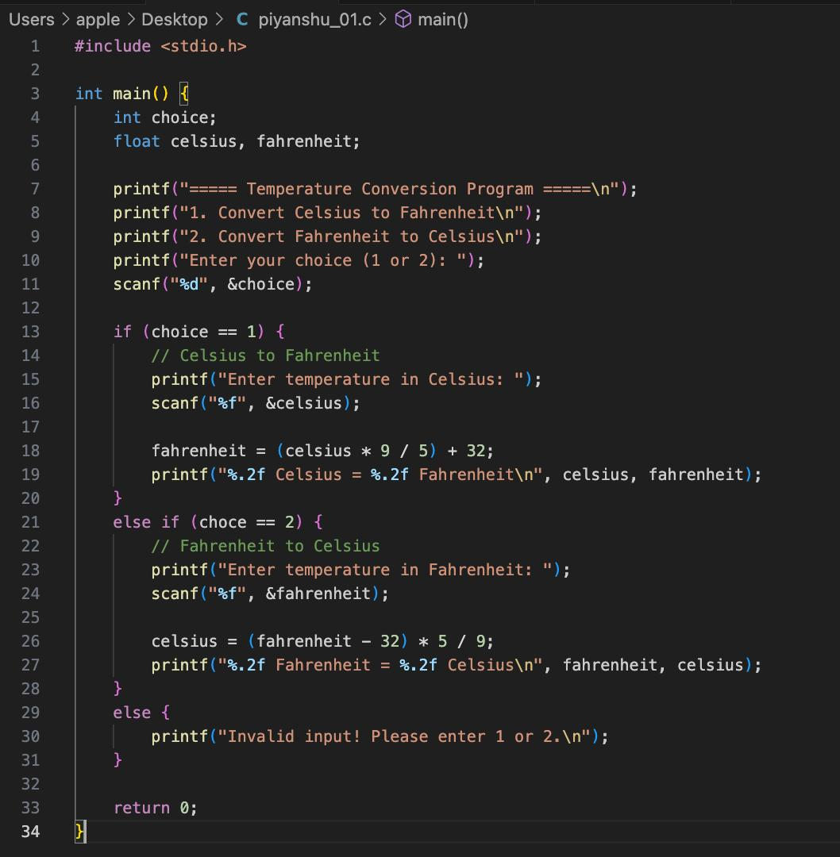

Output :

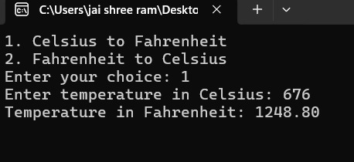

**2)Write a C program Given an input positive integer number, display odd numbers from in the range [1,n]**

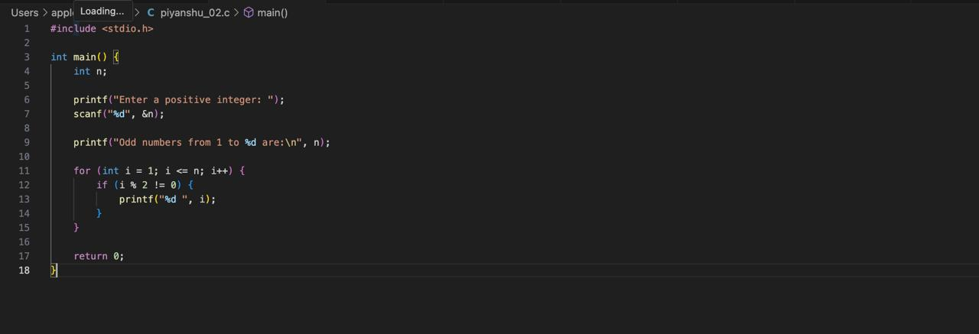

**Output:**

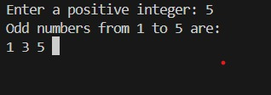

**3) Display the first n (n > 0) terms of the Fibonacci sequence**

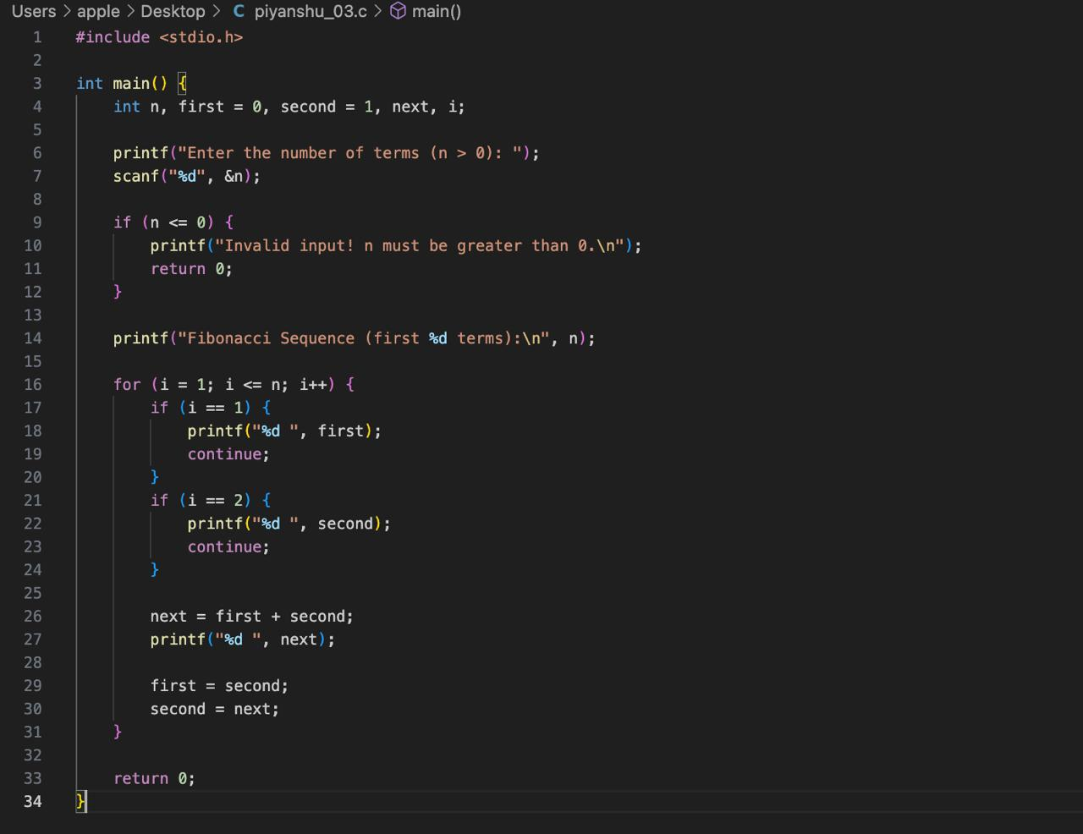

**Output :**



**4)Write a Program to Extract digits of an integer number (left to right and right to left)?**

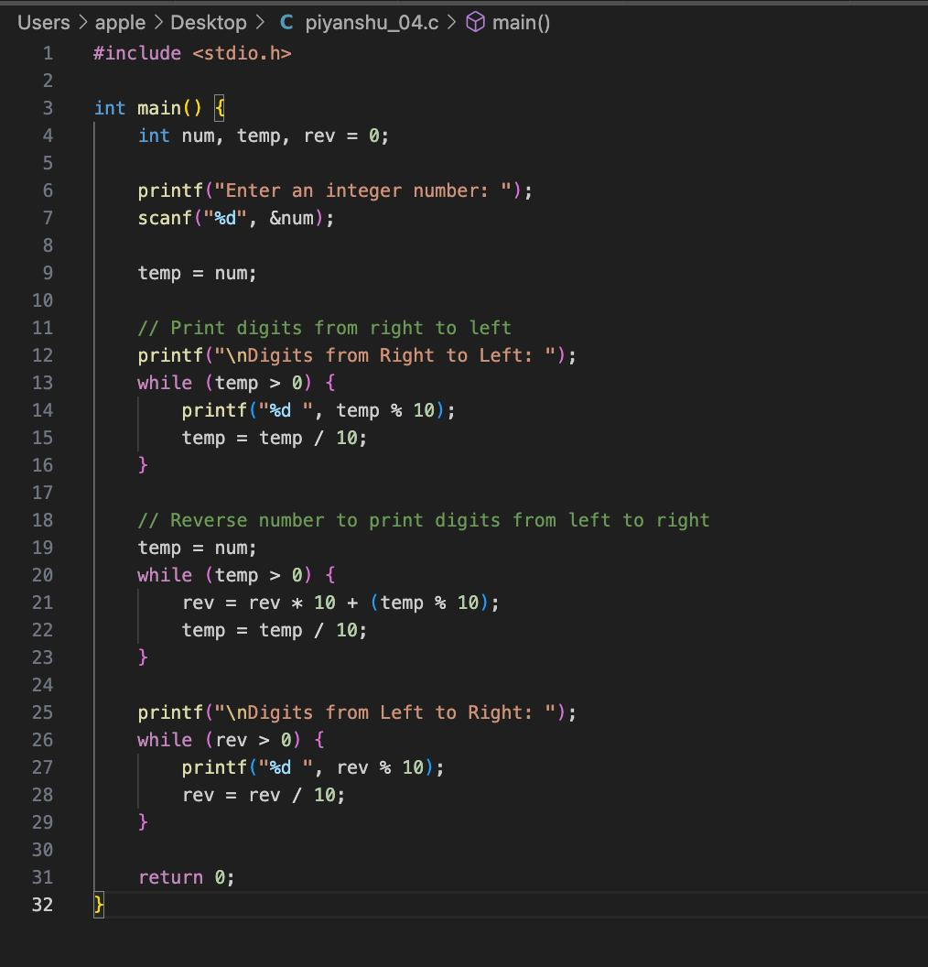

**Output :**

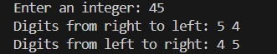

**5)Write a Program Given a sequence of digits form the number composed of the digits. Use sentinel controlled repetition to read the digits followed by -1. For example, for the input 2 7 3 2 9 -1 the output number is 27329?**

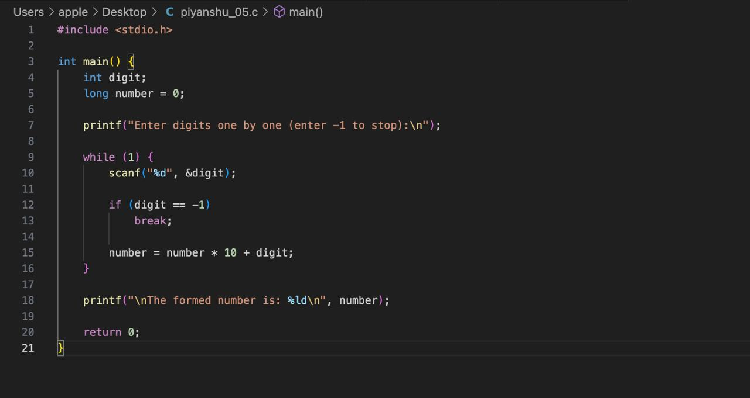

**Output :**



**6) Write a Program Check if a given positive integer number is a palindrome or not?**

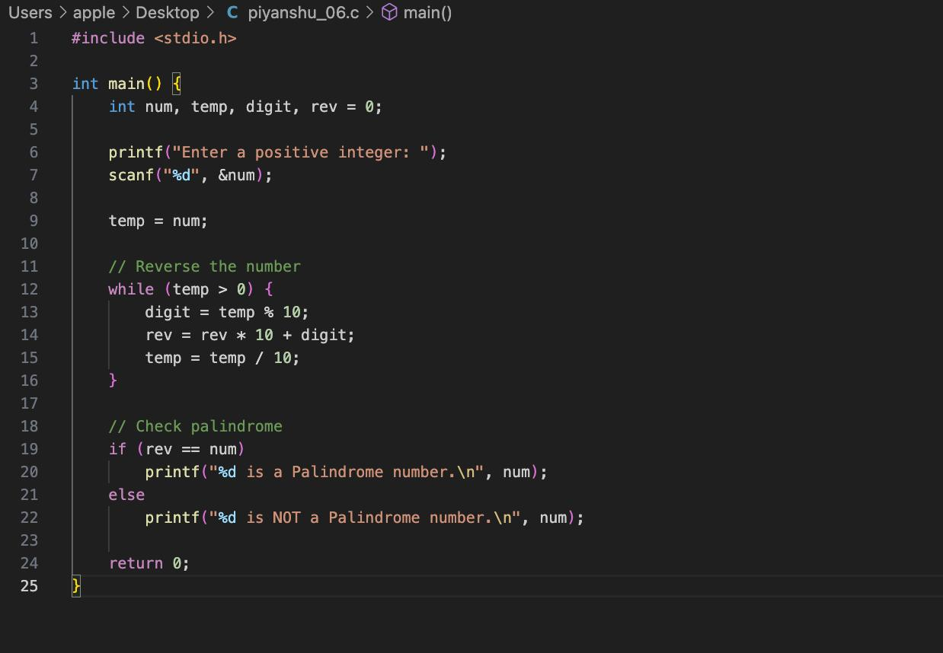

**Output :**



**7)Write a Program Check if a given positive integer number is a prime number or not?**

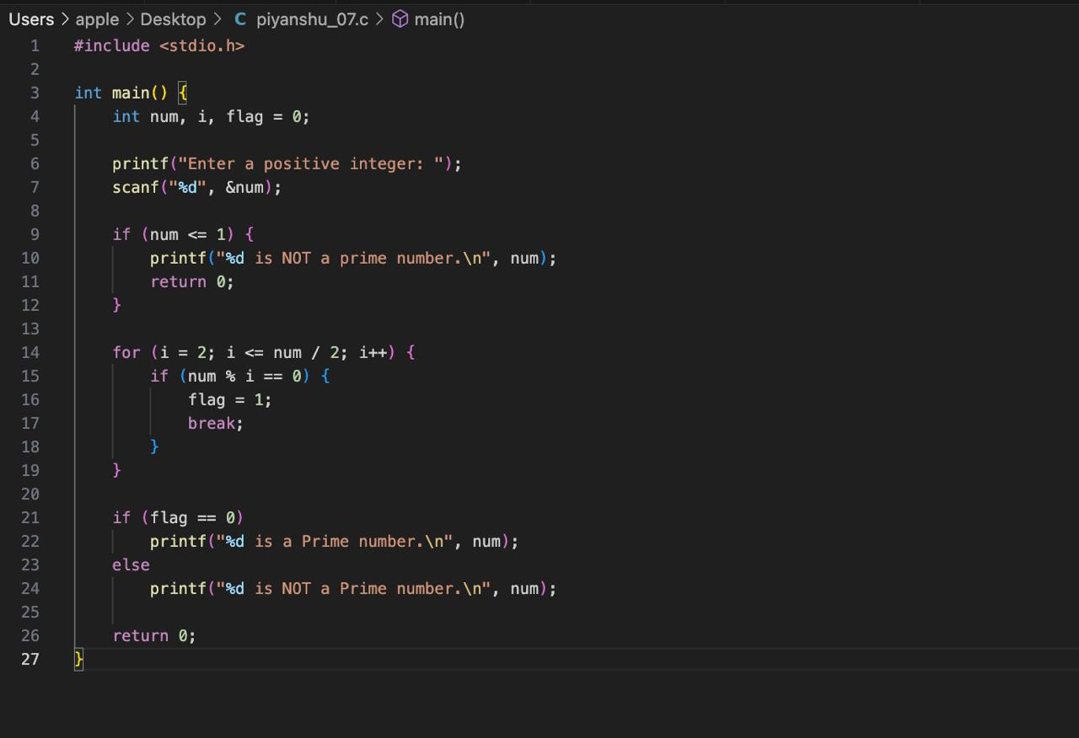**Output :**



**8)Compute prime factors of a positive integer number.**

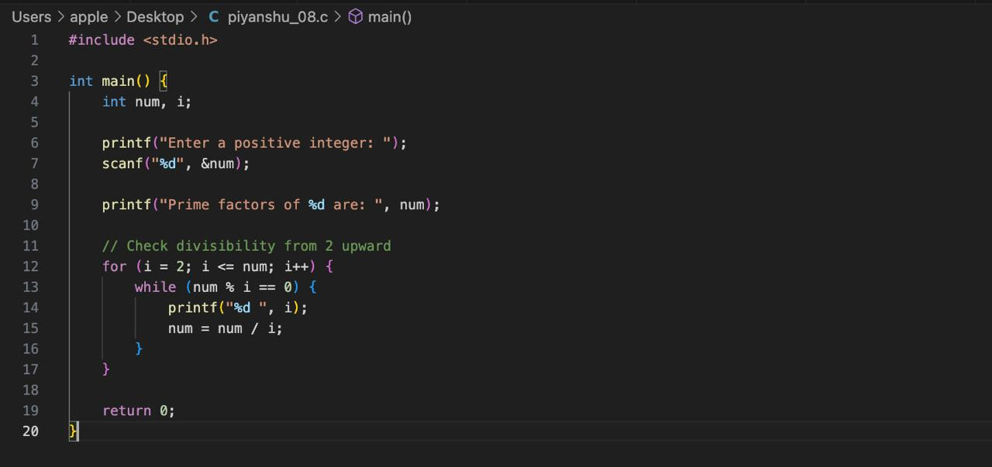

**Output :**



**9)Write a Program Check if two positive integer numbers are amicable numbers or not**

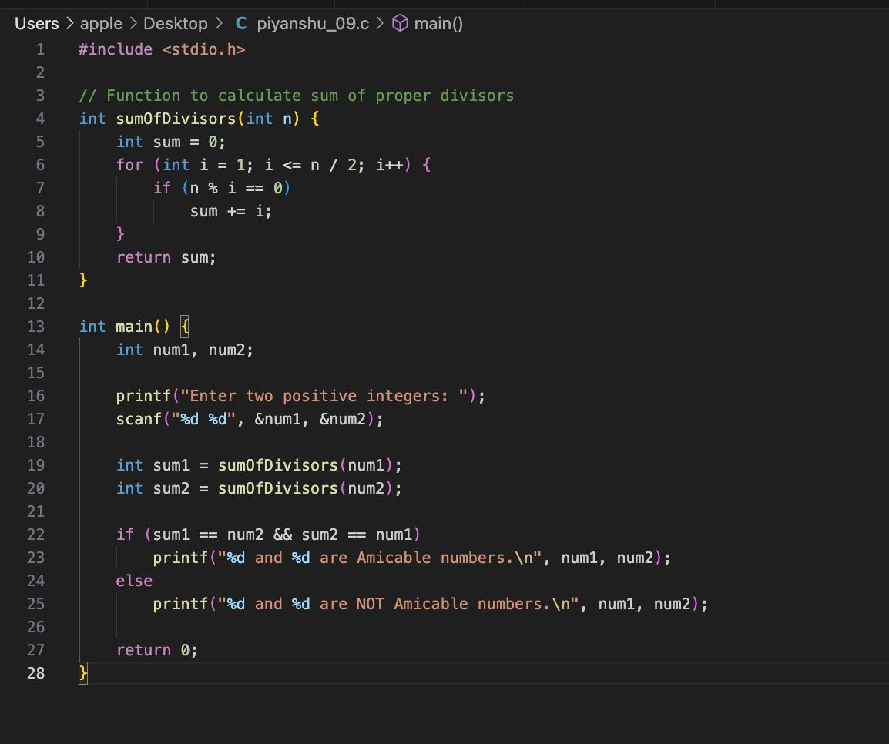

**Output :**



**10)Write a Program Check if a given positive integer number is a perfect number or not**

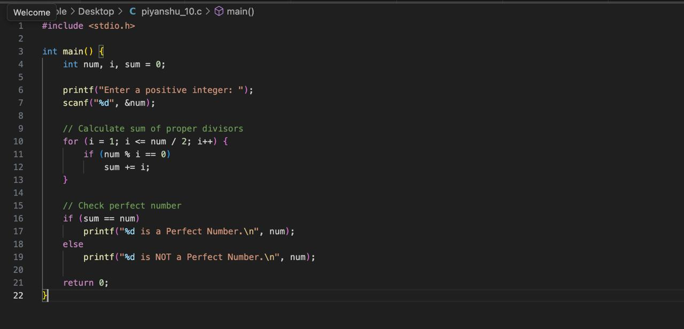

**Output :**



**11) Write a Program Check if a given positive integer number Armstrong number or not**

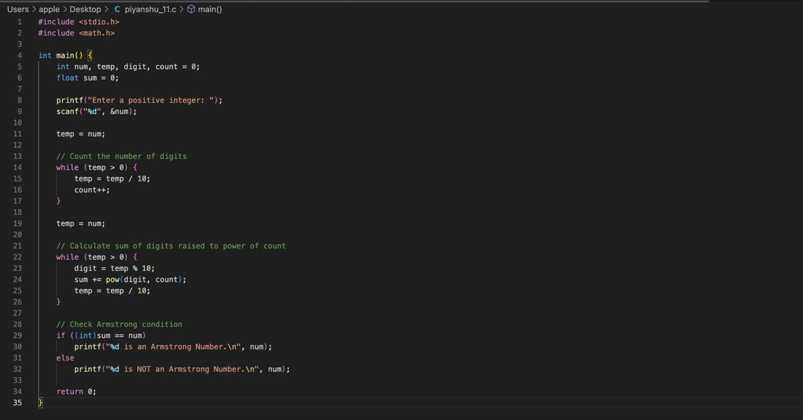

**Output :**



**12) Compute maximum, minimum, sum and average of a sequence of numbers which are read using sentinel controlled repetition using only few variables?**

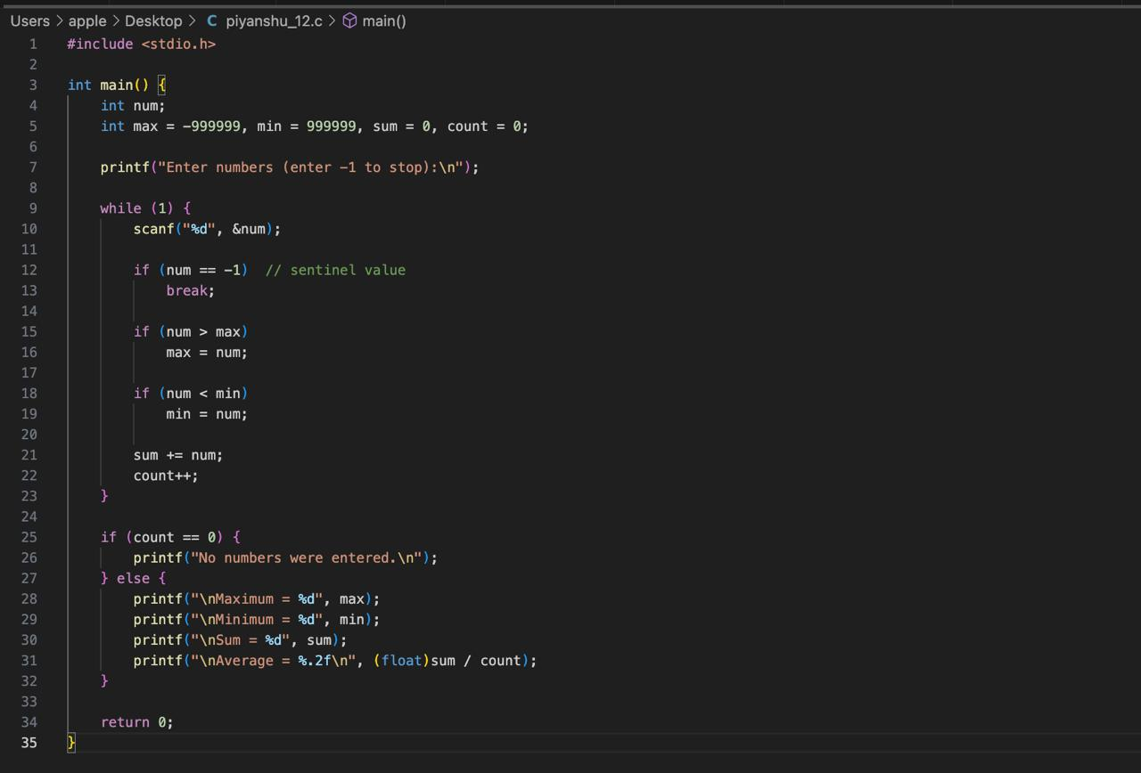

**Output :**

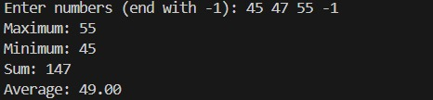

**13) Design a modularized algorithm/program to check if a given positive integer number is a circular prime or not?**



**Output :**



**14) Design a modularized algorithm/program to compute a maximum of 8 numbers**

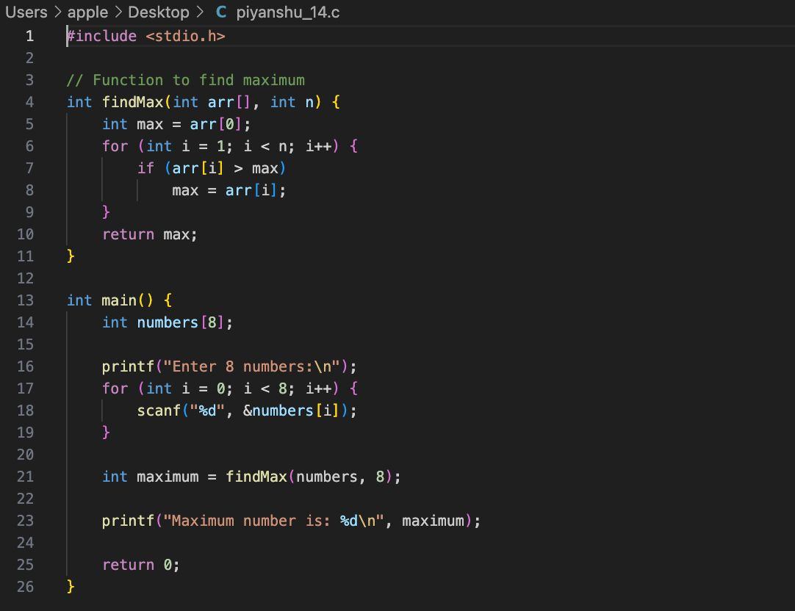

**Output :**



15) Design a modular algorithm/program which reads an array of n integer elements and outputs mean (average), range (max-min) and mode (most frequent elements)

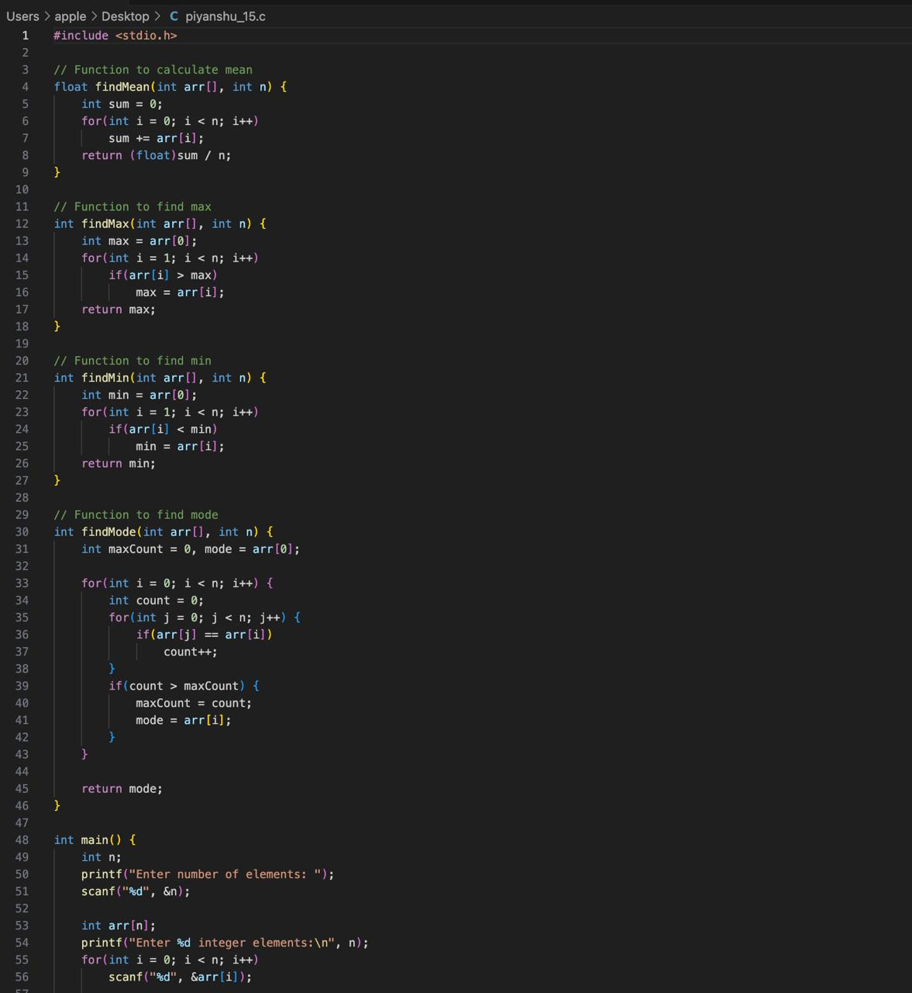

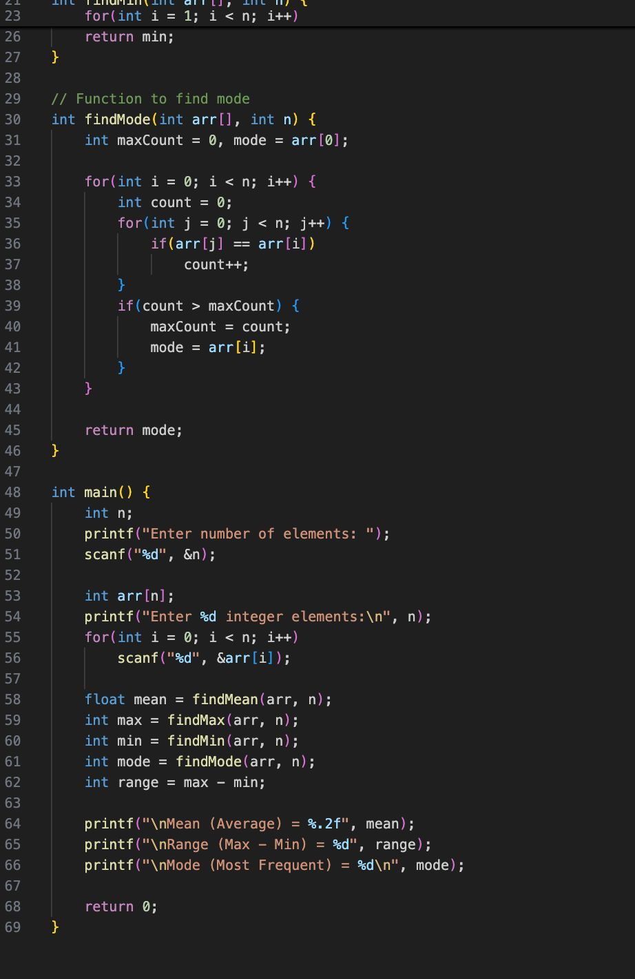

**Output :**

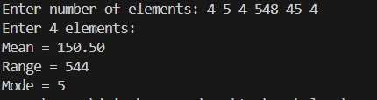

16) Display the first n (n > 0) terms of the Tribonacci sequence?

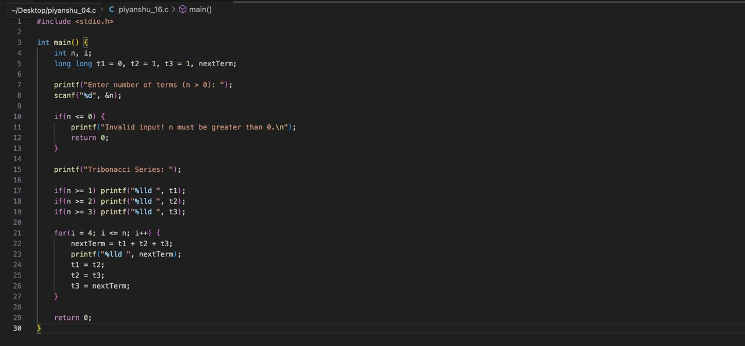

**Output :**



17) Write a Program to Implement your own string length and string reversal functions

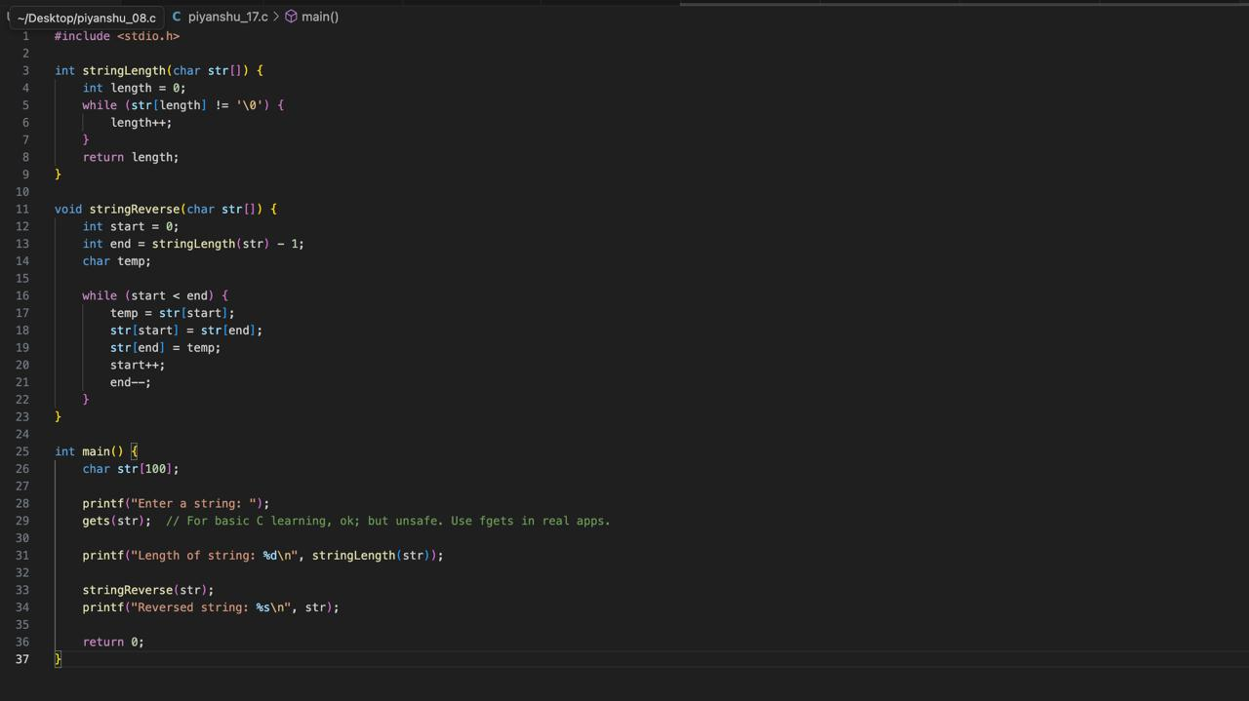

**Output :**

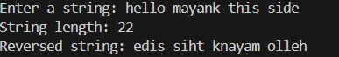

18) Design algorithm/program to perform matrix operations addition, subtraction and transpose

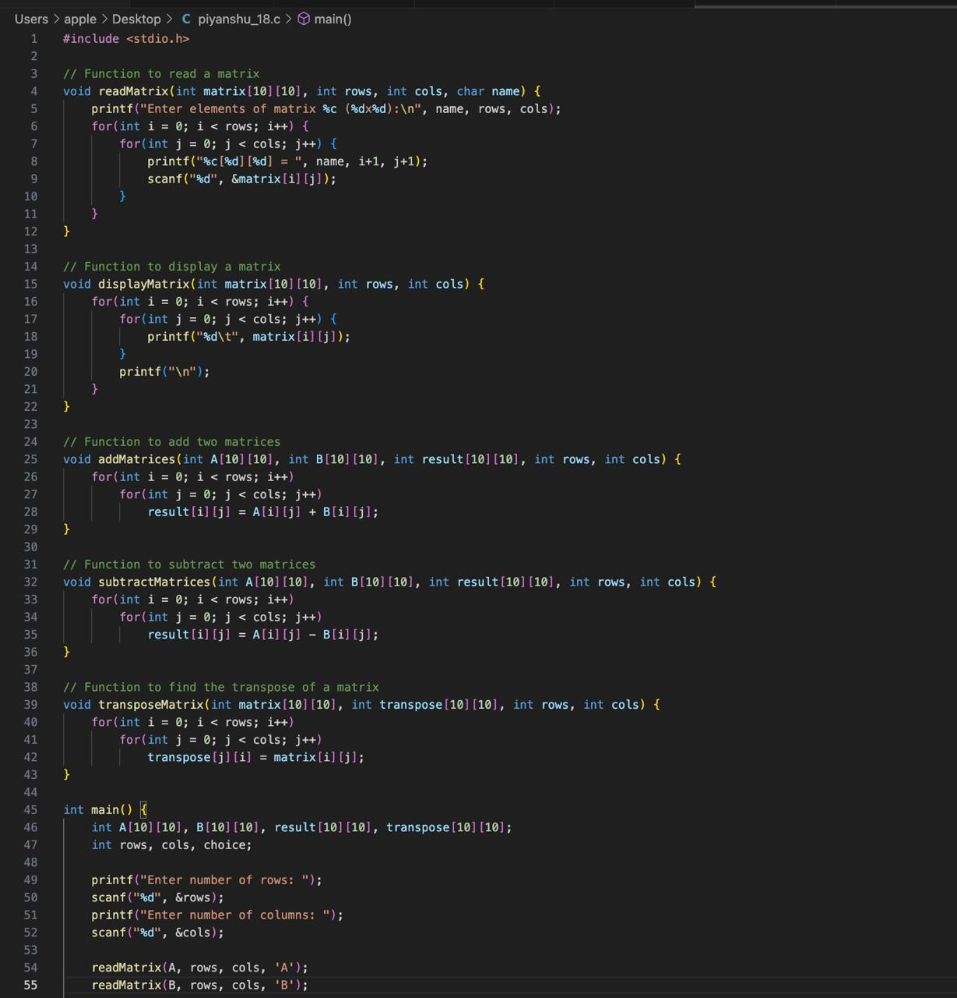

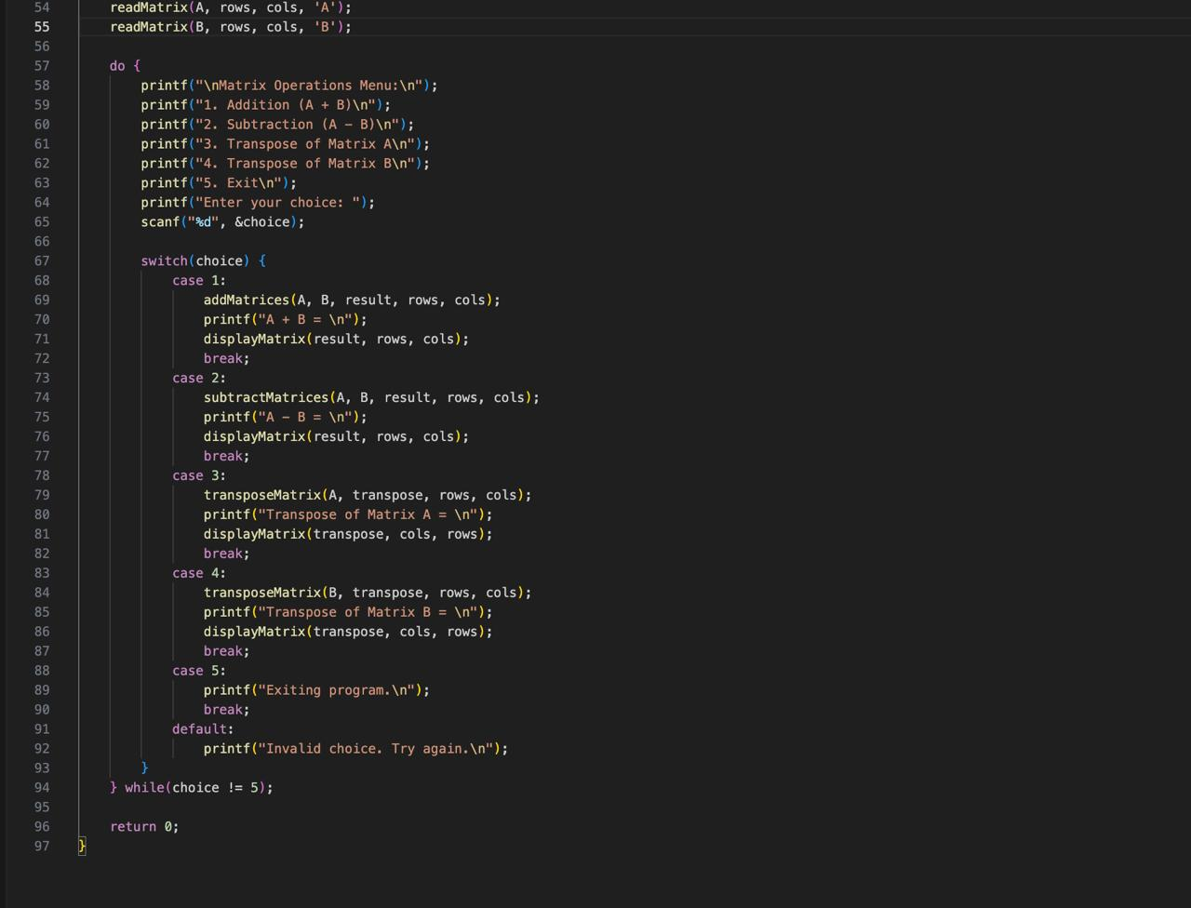

**Output :**

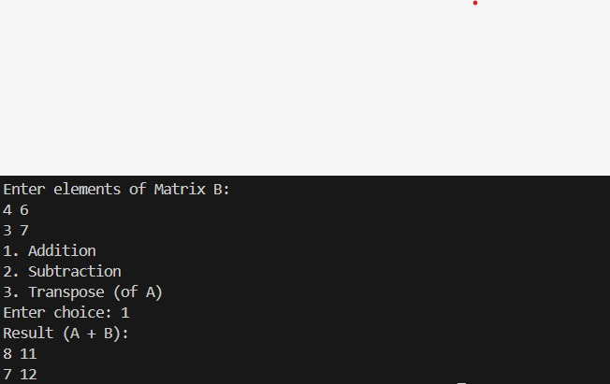

19) Write a recursive program to count the number of digits of a positive integer number

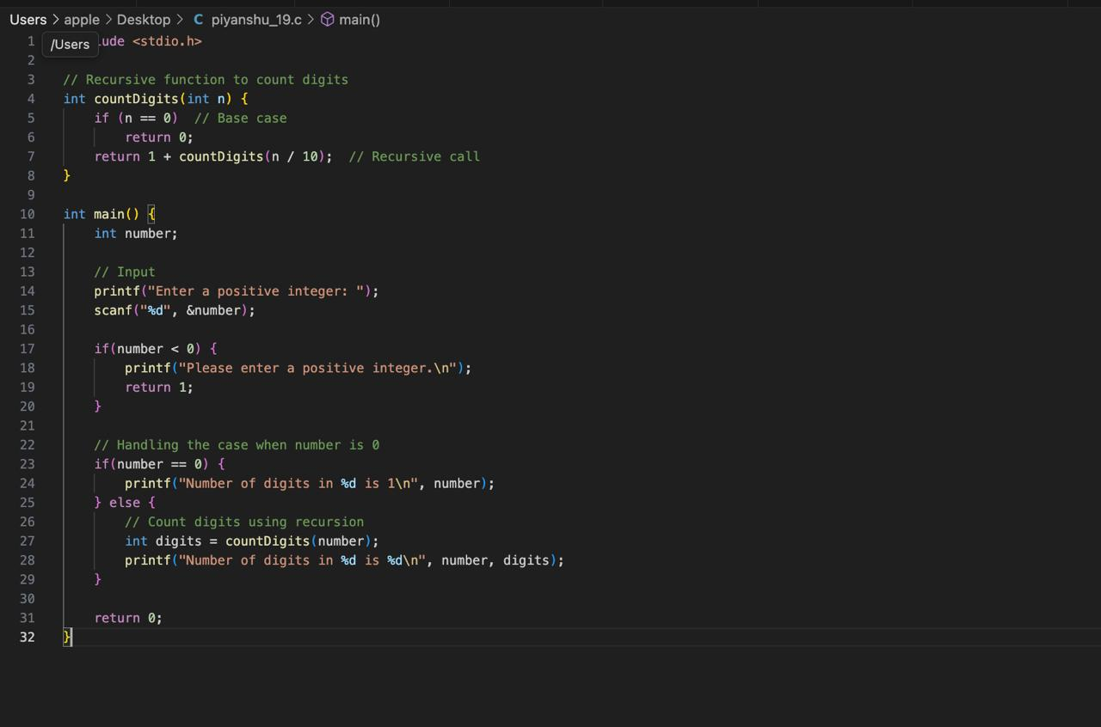

**Output :**



20) Write a Program Recursive solutions for the following problems: a. Factorial of a number? b. Display digits of a number from left to right (and right to left)? c. Compute xy using only multiplication?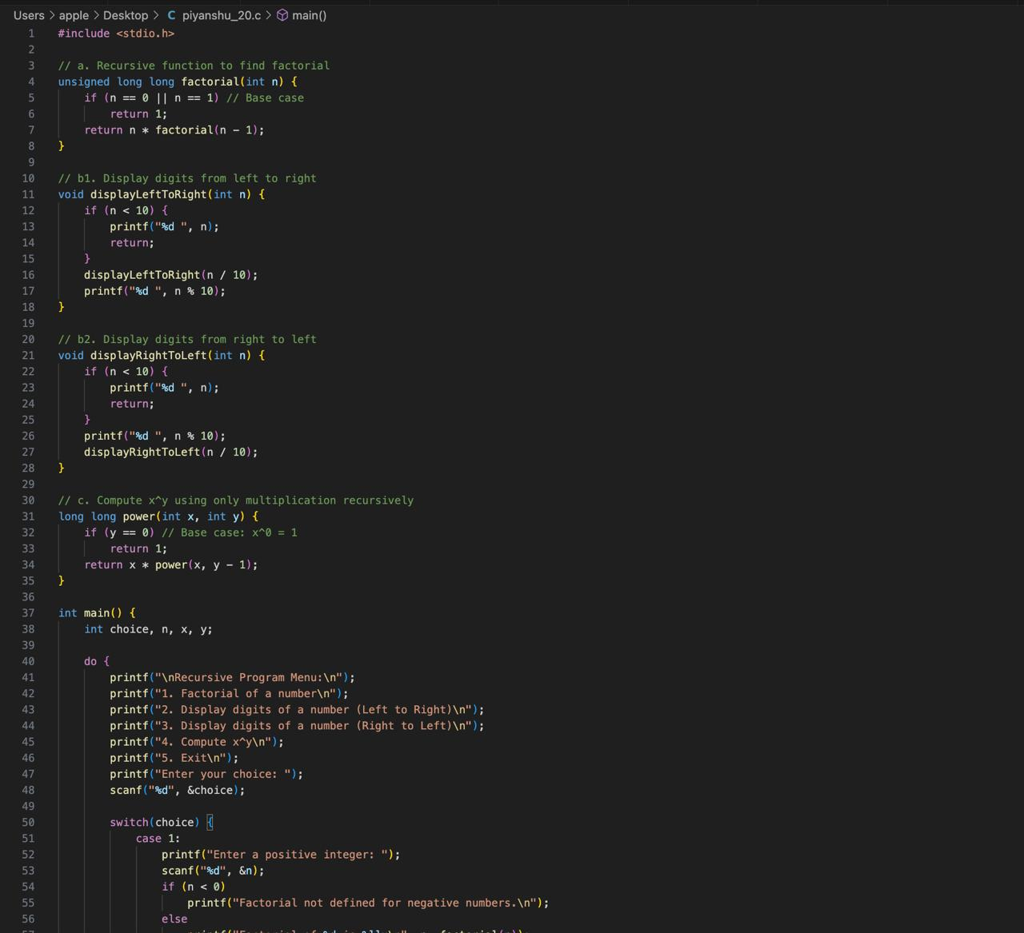

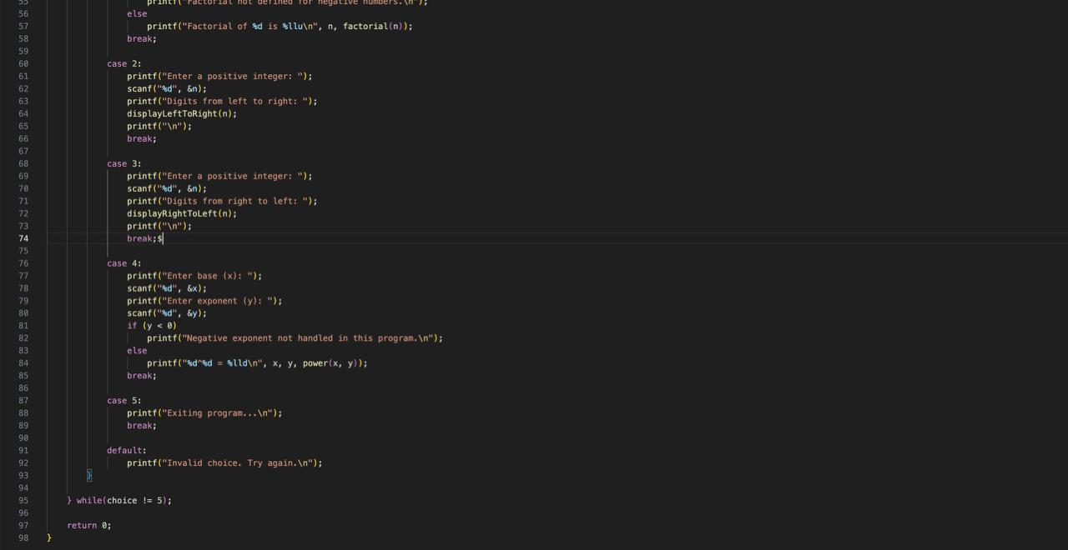

**Output :**

